Linux Commands
- pwd
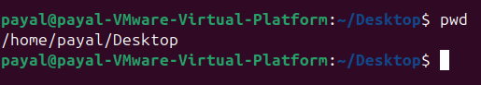
- mkdir + ls
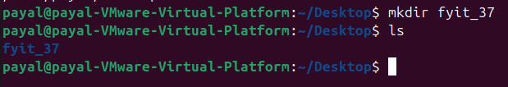
- rmdir + ls
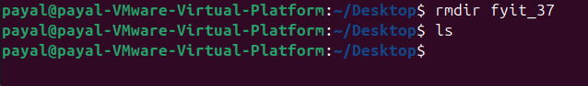
- touch + ls
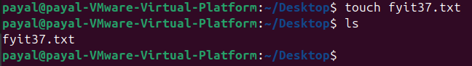
- rm+ ls
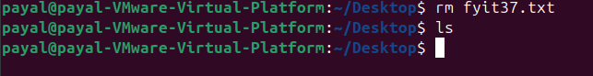

- cat
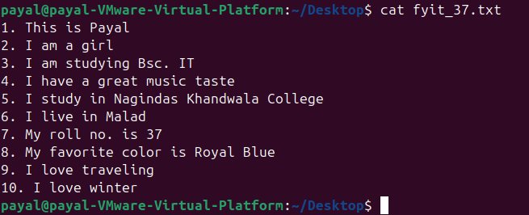
- tac
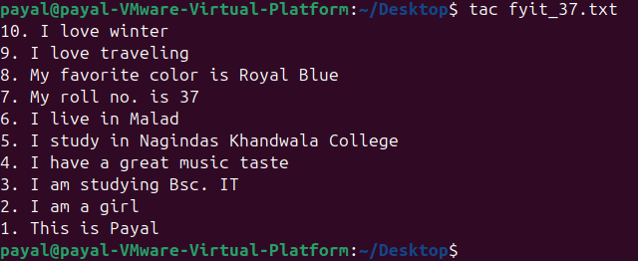
- head
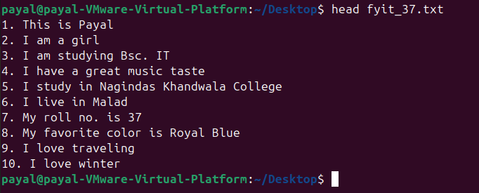

- tail
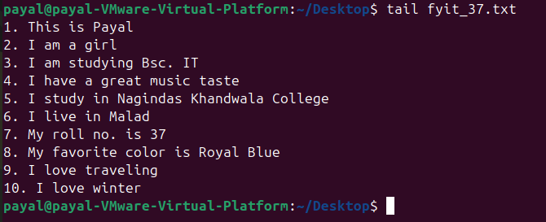
- more
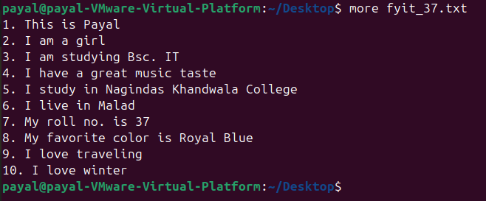

- less
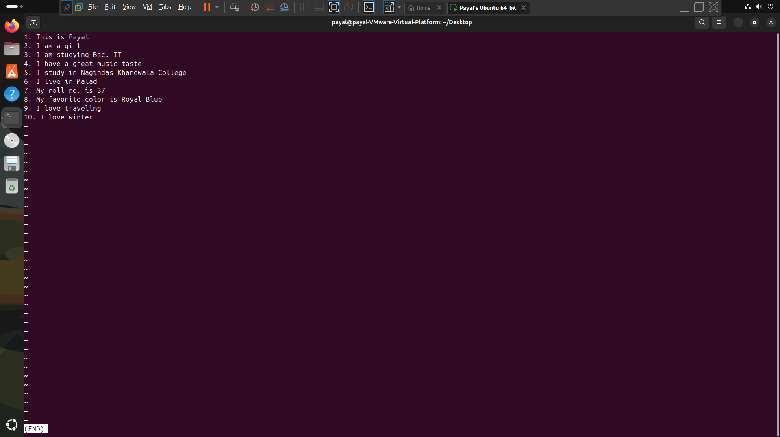
- grep
- date
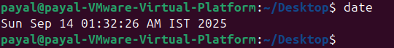
- cal
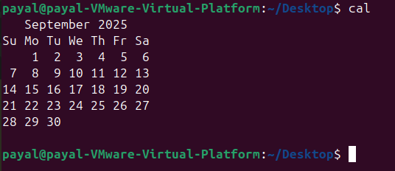

- uptime
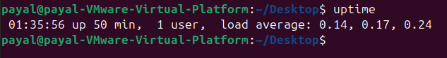
- w
- whoami
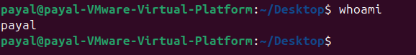
- sudo su (su=superuser) [input password after the command]
